**Message Management**

**Client Side**

Client Home Page (Submit A Message Page)

All Messages (Viewing All Messages Sent and Received by Client)

Reply Action

Viewing Individual Reply

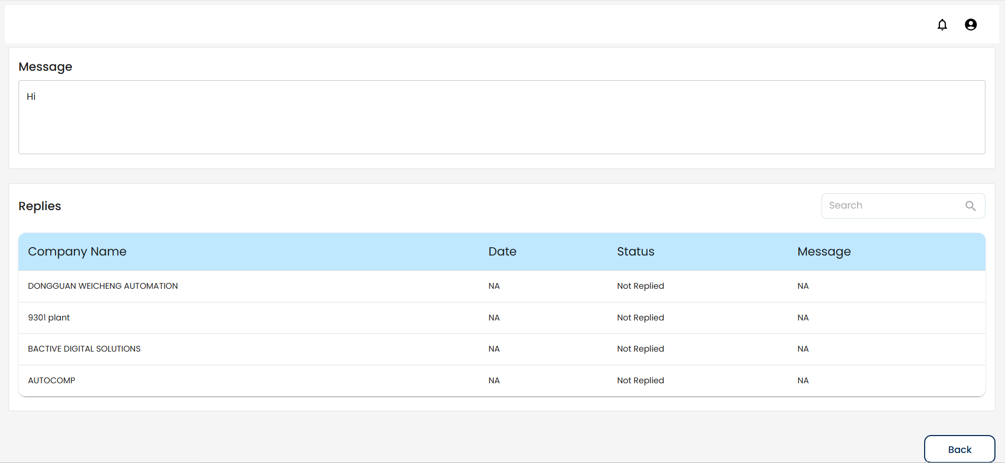

**Vendor Side**

Vendor Home Page (Submit A Message Page)

All Messages (Viewing All Messages Sent and Received by Vendor)

Reply Action

Viewing Individual Reply

